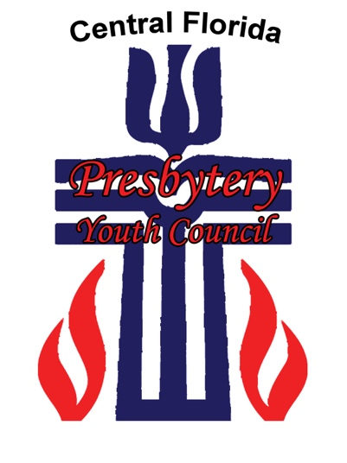
Central Florida Presbytery
Presbytery Youth Council
2023-2025 Job Description

Serving on the Presbytery Youth Council is a unique way for high school youth to grow in their faith in Jesus Christ. Youth who serve on the PYC will also gain valuable leadership skills, learn more about the Presbyterian Church (USA), forge lasting friendships, and serve the church in an important, challenging way. The Presbytery Youth Council is composed of youth and adults from Central Florida Presbytery. No more than two youth from the same church may serve on the Presbytery Youth Council with a maximum number of youth being 20. Youth serving on the Presbytery Youth Council are nominated by their churches through an application process. Adults and youth serve on the Presbytery Youth Council in a 1:5 ratio.

The Presbytery Youth Council of the Central Florida Presbytery has primary responsibilities for:
- Planning and implementing Presbytery-wide youth events and retreats.
- Providing a balance of quality programming that offers opportunities for fellowship, study, service, worship, and discipleship.
- Promoting opportunities for youth participation in the Presbytery, Synod, and General Assembly.
- Serving as liaisons for promotion and communication of events between local churches and the Presbytery Youth Council

Youth who serve on the Presbytery Youth Council must:
- Be active participants in their local church and youth group.
- Be between the summer before 9th grade and the summer before 12th grade.
- Be an exemplary role model for other youth and refrain from abuse of any controlled substances (drugs, alcohol, and tobacco).
- Be willing to learn new skills and take risks in leadership roles.
- Be willing to commit to making the Presbytery Youth Council a priority in their schedules and be regular in attendance at meetings and events. Usually 7 meetings/events per year.
- Be willing to abide by all PYC policies found in the by-laws.

Youth normally serve a two-year term. They are welcome to reapply at the end of two years but will be given the same consideration as all other applicants. The term will begin in August and end in June of the second year. The term for representatives joining the Presbytery Youth Council in January will extend through June of their second year.

Deadline to submit application: Friday, June 30, 2023
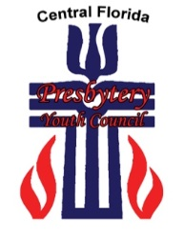
Central Florida Presbytery
Presbytery Youth Council
2023-2025 Application

Youth’s Name:_______________________________ Parent’s Name(s):____________________________
Youth’s Email:________________________________ Parent’s Email: _______________________________
Youth’s Cell Phone:__________________________ Parent’s Cell Phone: _________________________
Youth’s Birthday: _________________________ Grade:________ School:_______________________
Mailing Address:_____________________________ City:_________________________ Zip:_____________
Church:______________________________________
Youth/CE Advisor:___________________________ Advisor’s Email:______________________________

Please answer the following questions. Use additional paper, if needed.

- In what ways do you participate in your local church?

- What Presbytery Youth Council events have you participated in?

- Do you have a job? If so, what is it? How many hours per week do you normally work? Knowing that PYC events are on the weekend, how flexible is your employer about time off?

- In what extra-curricular activities are you involved? (athletics, clubs, lessons, band, hobbies, etc.) Do any of these require weekend participation?

- Why do you want to serve on the Presbytery Youth Council?

- What skills and gifts do you feel you have to contribute to the Presbytery Youth Council?

- What does your Christian faith mean to you and how do you express it in your day to day life?

- How do you feel serving on the Presbytery Youth Council will help you grow spiritually and nurture your faith?

I,_________________________, pledge to refrain from drugs, alcohol, and tobacco and to lead a life of faithfulness inside and outside of Presbytery Youth Council events and in my daily life.

Signature: ________________________________________________________________

Please return this application along with the Parental/Guardian Covenant form, the Medical Release Form, and Photo Publication Release Form to:
Kenne Sparks, CFP Youth & Collegiate Ministries Coordinator,
3101Maguire Blvd., Ste. 244 Orlando, FL 32803 or ksparks@cfpresbytery.org
by Friday June 30, 2023.

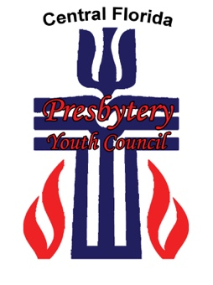
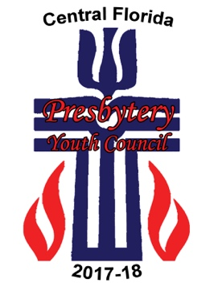
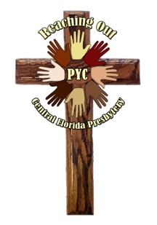
Central Florida Presbytery
2023-2025 Reference Form
(to be filled out by Pastor or Youth Leader)

The Youth listed below is applying for a two-year term on the Presbytery Youth Council of the Central Florida Presbytery. The position involves planning and implementing Presbytery-wide youth events for middle and senior high school youth. Attendance is necessary in order to participate fully in all the events and meetings. We desire youth to apply who have a strong faith in Jesus Christ and who are leaders in their churches.

We would appreciate your comments regarding this youth’s application for the position. Your comments will be kept strictly confidential.

NAME OF YOUTH APPLICANT: ______________________________________

- What skills, abilities, and leadership potential enable the applicant to be an effective member of the Presbytery Youth Council?

- Describe the character and strengths of the applicant.

- In what areas, if any, does the applicant need further growth and maturity?

- Do you perceive that the applicant’s family will be supportive of their participation in the Presbytery Youth Council if they are selected? Explain why or why not. In what ways is the applicant active in the life of your congregation?

- In what ways would this youth make a good role model and example for other youth? What concerns, if any, do you have in this area?

Reference Name Printed:_______________________________________________________________________

Signature of Reference:___________________________________________________________

Position in Church:______________________________________________________________

Please return this application along with the Parental/Guardian Covenant form, the Medical Release Form, and Photo Publication Release Form to:
Kenne Sparks, CFP Youth & Collegiate Ministries Coordinator,
3101Maguire Blvd., Ste. 244 Orlando, FL 32803 or ksparks@cfpresbytery.org
by Friday June 30, 2023.

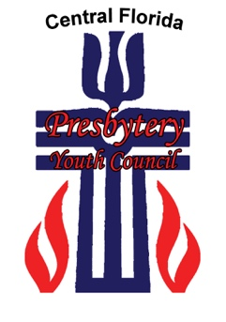
Central Florida Presbytery
Presbytery Youth Council
2023-2025 Parent/Guardian Covenant

- Will you work with your child to make Presbytery Youth Council a priority in your family’s schedule? Yes______ No_________

- How will transportation be provided for your child to and from Presbytery Youth Council events and meetings? Please list any concerns in this regard.

- How do you understand your child’s role in the Presbytery Youth Council? Why do you feel your child is a good applicant?

The Presbytery Youth Council offers its members the opportunity to serve the church and their peers as they plan and implement Presbytery-wide youth events. It is hard work that will need to be a priority in each member’s schedule. However, the experience is educational and rewarding. Presbytery Youth Council members will grow in their relationship with Jesus Christ, develop leadership and planning skills, experience unique opportunities, and make lasting friendships with other youth from around the Presbytery.

By the action of the Presbytery Youth Council all events and meetings are free of abuse of controlled substances. In signing this form we want you to be aware of this policy and understand that Presbytery Youth Council members who do not abide by the policy will be asked to leave the event/meeting and will be dismissed from the Presbytery Youth Council.

I am aware that ________________________________________ is applying for a position on the Presbytery Youth Council of Central Florida. I have read the job description for Presbytery Youth Council members and the by-laws. I will support my child’s participation on the Presbytery Youth Council if selected.

Signature of Parent/Guardian:________________________________________

Printed Name:_____________________________________________________

Date: _________________

Please return this Covenant, the Medical Release Form, and Photo Publication Release Form to:
Kenne Sparks, CFP Youth & Collegiate Ministries Coordinator,
3101Maguire Blvd., Ste. 244 Orlando, FL 32803 or ksparks@cfpresbytery.org
by Friday June 30, 2023.

CENTRAL FLORIDA PRESBYTERY

PRESBYTERY YOUTH COUNCIL (PYC)

2023-2025

PERMISSION/MEDICAL RELEASE FORM

YOUTH’S NAME:____________________________________

DATE OF BIRTH:_________________________

ADDRESS: ___________________________________________________________________

NAME OF PARENT OR GUARDIAN:_____________________________________________

PARENT’S CELL/WK PHONE:____________________ HM PHONE: __________________

PARENT(S) MEDICAL INSURANCE COMPANY___________________________________

GROUP #___________________________ SOCIAL SECURITY #_________________

CHILD’S ALLERGIES__________________________________________________________

______________________________________________________________________________
MEDICATIONS CURRENTLY BEING TAKEN BY CHILD:___________________________

______________________________________________________________________________
MEDICATION INSTRUCTIONS (if needed):________________________________________

EMERGENCY CONTACTS:

1ST CHOICE__________________________ PHONE #___________________________

2ND CHOICE__________________________ PHONE #___________________________

I give permission for my child to be transported by an authorized adult in a personal vehicle.

EMERGENCY AUTHORIZATION: In the event I cannot be reached in case of an emergency, I hereby give permission to the physician selected by the Central Florida Presbytery’s Leadership Development and Resourcing Coordinator or other Designated Adult Presbytery Youth Advisor to hospitalize, secure proper treatment for, and to order injections, anesthesia, or surgery for my child as named above.
___________________________________
Parent or Guardian’s Signature/Date

Central Florida Presbytery Youth Council
2023-2025 Parental Consent Form
Photo Publication

Central Florida Presbytery does not publish photos of minor children/youth without the consent of a parent or guardian. If you are willing for your child’s photo(s), taken at the event named below, to be published, we ask that you read this consent form, sign and date it, and return it to us.

Please note that we DO NOT publish the LAST NAMES of individual minors and are asking consent to publish images, first names, and church only.

PERMISSION FOR PYC MEETINGS & EVENTS 2023-2025

Central Florida Presbytery has my permission to use photos of my minor child taken at this event in print form and/or electronically, including on the Presbytery’s website.

Minor’s Name_____________________________________________________________

Parent/Guardian Name (print)_______________________________________________

Parent/Guardian Signature (mm/dd/yy)________________________________________

Central Florida Presbytery
3101 Maguire Blvd. Ste. 244
Orlando, FL 32803
Phone: 407-422-7125 ext 209
Fax: 407-422-7128
Email: ksparks@cfpresbytery.org
Website: www.cfpresbytery.org

