CORONAVIRUS UPDATE – July 15, 2020

CURRENT SITUATION
The past month has seen a dramatic increase in the number of positive cases in Florida, and within the bounds of Central Florida Presbytery. The following chart is a comparison of data that was included in an update on June 9, compared with current data (as of July 14).
 |  | 6/8/2020 |  |  | 7/14/2020
COUNTY | Positive | Hospital | Death | Positive | Hospital | Death
Volusia | 837 | 164 | 46 | 4,355 | 341 | 79
Seminole | 556 | 117 | 12 | 4,665 | 222 | 28
Lake | 339 | 82 | 15 | 2,882 | 159 | 26
Sumter | 264 | 45 | 17 | 721 | 86 | 18
Orange | 2,449 | 390 | 45 | 19,909 | 635 | 94
Osceola | 762 | 165 | 21 | 4,751 | 250 | 371
Brevard | 471 | 73 | 13 | 3,722 | 234 | 40
Indian River | 167 | 37 | 11 | 1,386 | 100 | 22
Okeechobee | 143 | 13 | 0 | 566 | 55 | 2
Highlands | 150 | 41 | 9 | 627 | 94 | 13
 | 6,138 | 1,127 | 189 | 43,584 | 2,176 | 693

In Florida, over half of the positive cases are in south Florida. One-third of the cases are in the counties along the I-4 corridor. Around 15% of the cases are in the rest of the state.

More people under the age of 65 are being tested since the state entered Phase 2 of its reopening plan, so it is not surprising that half of the positive results over the past month has been from people in their 20’s and early 30’s. The median age of persons testing positive has dropped from the low 50’s to 39 statewide. Most of the Presbytery’s counties are under this median, except for Lake (40), Volusia (42), and Sumter (62). Here is the age distribution of positive cases statewide:
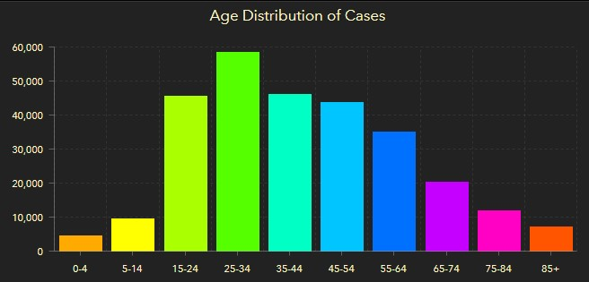

In part because of these increases, some of our congregations have paused or delayed their return to in-person worship and other activities. The latest report of what our congregations are doing can be found here. If your congregation has recently made changes to your worship strategy, please send that information to Cheryl Carson. Sessions are reminded of the guidance provided by the Centers for Disease Control on COVID-19 mitigation, prevention and support as churches consider further steps to open, or need to respond to an incident of infection within the church setting.

Several counties and communities within our presbytery have mandatory mask protocols in place for when people are in public places. This is an anecdotal account, but recently I was exposed to someone who tested positive, a staff member at my doctor’s office. I completed two weeks of self-quarantine without any symptoms of the virus. Wearing a mask while at the appointment certainly helped protect me for infection. The incidence of virus transmission is dramatically lessened when we continue to follow CDC guidelines, including frequent hand washing and wearing a mask. The mask protects us from other people, but more importantly, protects other people from us.

A COUPLE REMINDERS
I have responded to questions often since the pandemic started about whether congregations and sessions can meet virtually, and what business can be handled. If the congregation’s bylaws define a virtual meeting as an approved form of meeting, anything that can be done in person can be done in a virtual meeting. The key is to provide an environment where simultaneous aural communication (ability to speak and Be heard) is possible. See the guidance on amending bylaws to permit virtual meetings.

I recently received a question about required notice for a virtual meeting. The notice is the same as for calling an in-person special meeting. However, the call for the virtual meeting needs to include the information for how to join the meeting. Sessions are reminded that since the Form of Government was revised in 2011, each congregation can set its own quorum and reasonable notice requirements for meetings. Many congregations have continued the old 10% of active members and two-week’s notice requirements, but these can be different if the congregation desires them to be.
- G-1.0501: All active members of the congregation present at either annual or special meetings are entitled to vote. Congregations shall provide by rule the quorum necessary to conduct business.
- G-1.0502: Adequate public notice of all congregational meetings shall be given. Congregations shall provide by their own rule for minimum notification requirements and give notice at regular services of worship prior to the meeting.

Dan Williams
Executive Presbyter / Stated Clerk

